CSE 3241 Project

Part 1

Nico Poggio.1

Casey Curran.232

Connor Stevens.1224

Nathan Johnson.9254

**Research:**

1. Interview with Dentist:
   1. How do you store data throughout your practice?
      1. I use a specific dental database called Dentrix to store patient information. Patient information includes medical history, X-rays, insurance information, and billing information.
   2. What data do you store on patients and employees?
      1. For patients: names, phone numbers, addresses, date of birth, gender, email, insurance information which normally includes SSN, billing address, insurance cards
      2. For employees: scheduling, names, addresses, phone numbers, SSN, wage/salary, position, employee ID
   3. How does your scheduling process work?
      1. A patient calls in to the office and works with the receptionist to schedule an appointment. The receptionist asks them for what procedures they need and finds a time that works between them. Depending on the procedure, the receptionist will ask follow up questions to get an idea of what information the dentist will need for the appointment.
   4. How do patients pay for appointments? How is insurance involved?
      1. Not all patients have insurance. If they do, we will file their insurance for them and then will charge the patient for the remaining amount after insurance pays for a portion. The amount that insurance will pay depends on the specific insurance company and policy.
   5. Do you accept all insurance policies? How do you determine what not to accept?
      1. No, I do not accept all insurance policies. I do not participate in volume-based insurance plans because they only pay 50% of the total cost, so I essentially lose money for specific plans. Determining what not to accept is a matter of whether the insurance company will pay enough and the patient is willing to cover the rest out of pocket.
   6. What information do you need from a patient when scheduling an appointment
      1. Name, phone number, basic medical history questions, whether or not they have insurance and what the insurance company is to know if we accept it or not, how long since they’ve last been into the dentist
2. Appointment Scheduling Strategies Article
   1. <https://pocketdentistry.com/12-appointment-scheduling-strategies/>
   2. This article provides information about the scheduling processes of a dental office. As explained in the article, most offices utilize one of two scheduling strategies. The first is overbooking specific blocks of time with multiple appointments to ensure the office always stays busy. This prevents downtime in the case of cancellations. The second strategy consists of stacking appointments so they do not overlap at all. In terms of the actual appointments, the article discusses the importance of categorizing appointments by time blocks. For example, a filling may take longer than an XRay, so it is important to keep track of how long those respective procedures will take and schedule appointments accordingly. Not only does each procedure have a different amount of time to complete the procedure, but each procedure has a different length of setup time to prepare for the actual procedure. Overall, the main takeaways from this article are the descriptions of the two main strategies for scheduling and how to keep track of the timing for each of the procedures.

**Entities and Relationships:**

Repeats are put under a new superclass

New super classes created:

PERSON (Generalized entity)

-Has patient & employee (disjoint)

* Person ID (***Key*** attribute)
* SSN (Attribute)
* First Name (Attribute)
* Last Name (Attribute)
* Date of Birth (Attribute)
* Address (Attribute)
* Email (Attribute)
* Phone Number (Attribute)
* Person Type (Attribute)

EMPLOYEE

-Has supervising attendant & medical professional (overlap)

PATIENT (Entity)

* HIPPA Form Signed Date (Attribute)
* Last X-Ray Date (Attribute)
* Insurance Info (***Foreign key*** to Insurance Policy)
* Medical History (***Foreign key*** to Medical History)
* Scheduling Preferences (***Foreign key*** to Scheduling Preferences)

INSURANCE_POLICY (Entity)

* Policy ID (***Key*** attribute)
* Insurance Company Name (Attribute)
* Policy Type (Attribute)
* Insurance Phone Number (Attribute)
* Policy Member ID (Attribute)
* Expiration Date (Attribute)

MEDICAL_HISTORY

* History ID (***Key*** attribute)
* Procedures (Multivalued attribute)
  + Procedure ID (***Key*** attribute)
  + Date (Attribute)
  + Name (Attribute)
  + Reason (Attribute)
* Medications (Multi-valued attribute)
* Allergies (Multi-valued attribute)
* Condition (Multi-valued attribute)

EMPLOYEE

* Employee ID (Key attribute)
  + Position (Attribute)
  + License Number (Attribute)
  + Hire Date (Attribute)
  + Availability (Foreign Key to Availability)

APPOINTMENT

* Appointment ID (Key attribute)
  + Date and Time (Attribute)
  + Status (Attribute)
  + Procedure(s) (Foreign Key to DENTAL_PROCEDURE)
  + Patient (Foreign Key)
  + Billing record (Foreign key to Billing Record)

DENTAL_PROCEDURE

* Procedure ID (Primary Key)
  + Procedure Name (Attribute)
  + Setup time (Attribute)
  + Procedure time (Attribute)
  + Total time (Attribute)
  + Standard Charge per Unit (Attribute)
* Insurance policy (Foreign Key to Insurance Policy)

INVOICE

* Invoice ID (Primary key)
  + Date due (Attribute)
  + Amount owed (Derived Attribute)
  + Cost before insurance (Derived Attribute)
  + Cost after insurance (Derived Attribute)
  + Status (Attribute)
  + Patient (Foreign key to Patient)
  + Appointment (Foreign key to Appointment)

PAYMENT (Generalized entity)

* Payment ID (Key attribute)
  + Amount (Attribute)
  + Date (Attribute)
  + Payment Type (Attribute)
  + Invoice (Foreign key to invoice)

**Additional Features:**

SCHEDULING_PREFERENCE:

* Patient (Foreign key)
* Preference ID (Primary key)
  + Start time (Attribute)
  + End time (Attribute)
  + Day (Attribute)

EMPLOYEE SHIFT:

* Shift ID (Primary key)
  + Employee (Foreign key)
  + Start time (Attribute)
  + End time (Attribute)
  + Date (Attribute)

**Relationships:**

* PATIENT - SCHEDULING_PREFERENCE (1 to many)
  + Ex. A patient can schedule their preferences for an appointment time
* PATIENT - MEDICAL_HISTORY (1 to 1)
  + Ex. The dentist can reference a patient's list of previous related or unrelated medical issues that may affect the appointment
* PATIENT - INSURANCE (1 to 1)
  + Ex. A patient can have an insurance company that can pay for the appointment.
* PATIENT - APPOINTMENT (1 to many)
  + Ex. A patient can schedule multiple appointment at a time
* EMPLOYEE - SHIFT(many to many)
  + Ex. An employee can schedule their available work days
* APPOINTMENT - EMPLOYEE (many to many)
  + Ex. An employee will be working at an appointment time
  + Ex. An employee schedules an employee time for patient and another employee
* APPOINTMENT - DENTAL_PROCEDURE (many to many)
  + Ex. There could be multiple appointments that require multiple dental procedures
* INVOICE - APPOINTMENT (1 to 1)
  + Ex. At the end of the appointment, a bill is generated based on the appointment specifications
* INVOICE - PATIENT (many to 1)
  + Ex. A patient receives one invoice based on the their appointment
* PAYMENT - INVOICE (many to 1)
  + Ex. A patient can pay off an invoice with multiple payments, either through insurance or out of pocket

**Types of Queries:**

* A patient's billing record
  + Doctors, other medical professionals, or secretaries can search up past patient appointments and charges based on patient ID, SSN, first and last name, email, or phone number. The query will pull up each appointment with information on when the appointment was, what it was for, and how much it cost.
* An employees availability
  + Managers can search up an employee's schedule based on Employee ID, or first and last name. Their schedule can be viewed and changed.
* Appointment availability
  + A receptionist can see all future appointments to see what times are available to schedule other appointments.
* The prices of each procedure
  + A receptionist can search up how much the base price of a procedure is, and how much it would cost after a patient's insurance is applied to it.

**EER Diagram:**

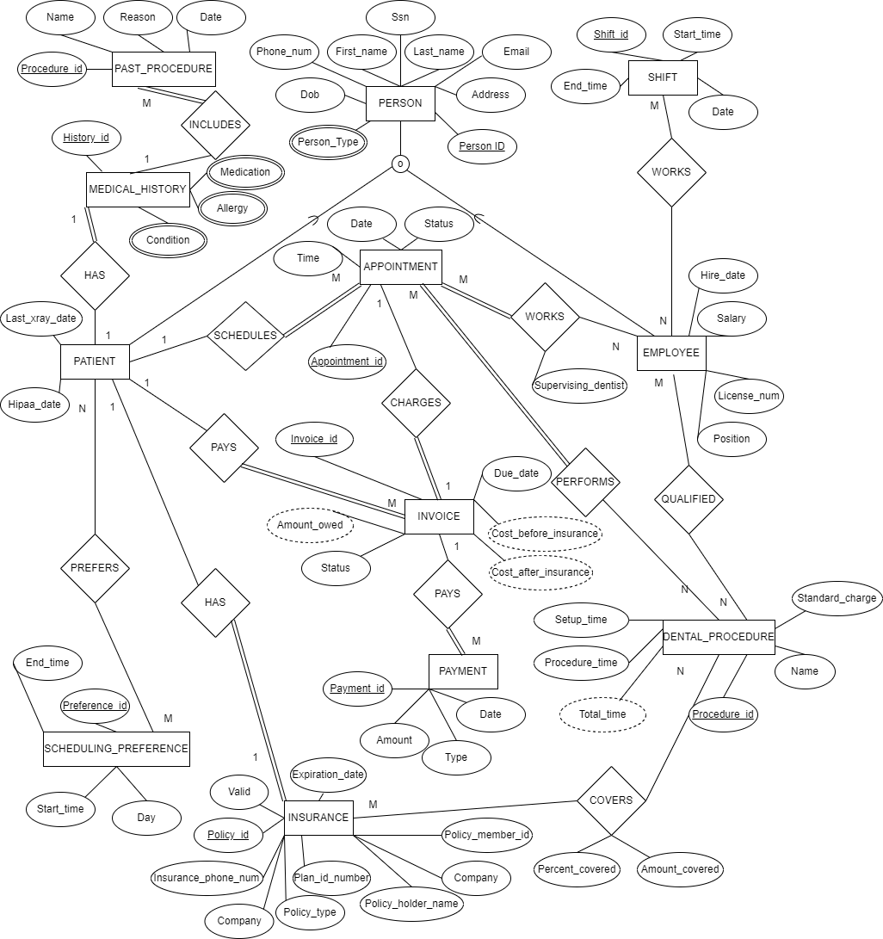

**SAMPLE DATA:**

Person Sheet:

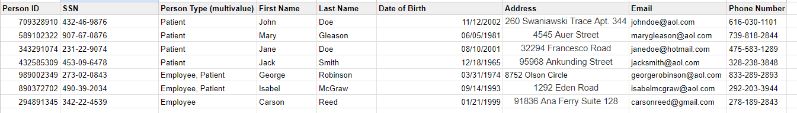

Patient Sheet:

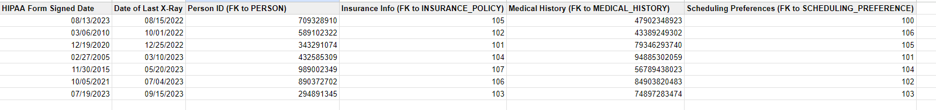

Employee Sheet:

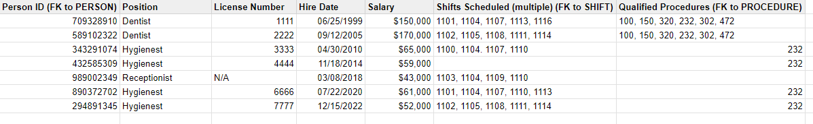

Dental Procedure Sheet:

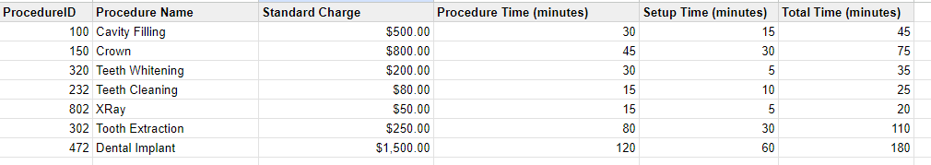

Insurance Policy Sheet:

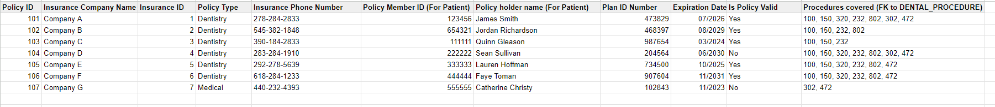

Past Procedure Sheet:

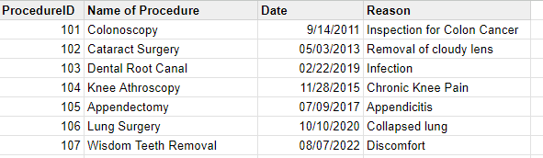

Appointment Sheet:

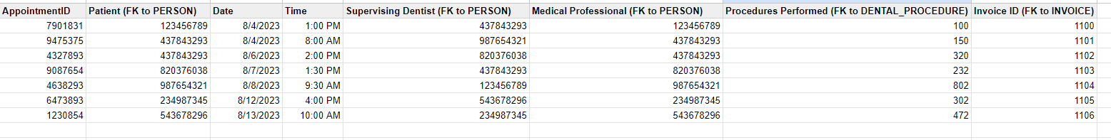

Invoice Sheet:

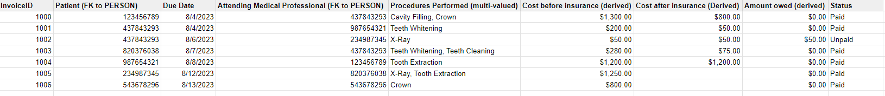

Payment Sheet:

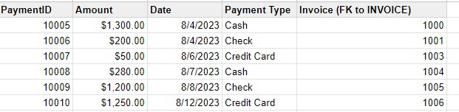

Scheduling Preference Sheet:

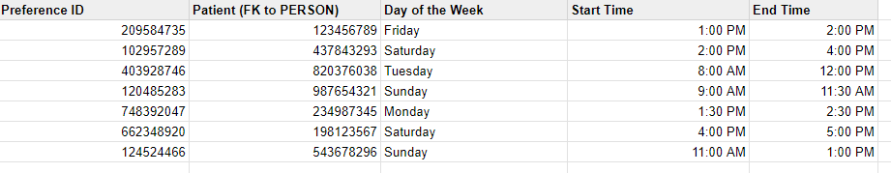

Shift Sheet:

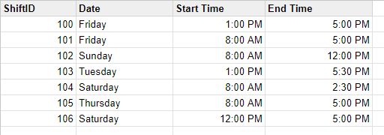

Medical History Sheet:

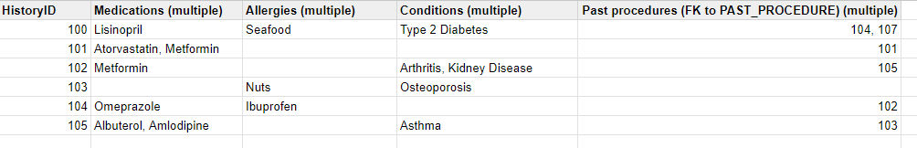

**CROSS-CHECK 1:**

For a new patient, we would create a new person and have them fill out their data on a form. This form would be used to create a new person in the person entity. They’d also fill out medical history, scheduling preferences, insurance, and payment. These would cover any past procedures the employees need to consider, medications, allergies, scheduling, any insurance information for the employees to consider, and how the patient will pay their invoice. The appointment would then need to be generated considering the scheduling preferences of the patient, the shifts of employees, and the dental procedures they are qualified for which could be done with a program. The employees in charge of the appointment would take in consideration medical history. The employees in charge of billing and insurance would make sure the patient’s billing and insurance were correct and worked for the appointment and the dental procedure.

**CROSS-CHECK 2:**

Once a patient has an appointment, the appointment will generate an invoice. The invoice has a due-date, amount owed (this is derived from what happened in the appointment), a status on whether or not it has been paid, a cost before insurance (derived from patient insurance plan), and a cost after the insurance (derived from the patient insurance plan). The patient can then pay the invoice with multiple payments. Each payment can be done through cash, check, or credit card and it is associated with a date and amount paid.

**CROSS-CHECK 3:**

The EERD provides necessary generalizations for patient and employee since there are a lot of duplicate attributes otherwise. Since an employee can be a patient and a patient can be an employee, there is overlap.

**Contributions:**

Nate: I did the first draft of the ER Diagram which was changed quite a bit, Cross-Check 1, Cross-Check 3, and updated relationships and excel sheets when needed.

Connor: Made the initial list of all entities, attributes, and relationships. After the ER diagram was complete, constructed a logically equivalent new one from scratch to improve organization and readability.

Nico: Contributed to making a list of entities attributes and relations. Edited and finalized the list in the doc. Created types of queries that the database can support. Contributed to Excel creation and ER diagram. Completed cross check 2.

Casey: Completed the interview and online research for the project. Contributed to building out the example spreadsheet. Contributed to editing and finalizing the ER diagram. Completed one of the queries the database can support.

Teamwork:

As a team, we were able to effectively communicate with each other over Discord and set a good timeline for ourselves. We started early and planned out meeting days so we would stay on track. We would assign tasks to each other and complete them individually, then we would come together as a team to review each other's work and brainstorm more ideas. Whoever was editing the ER diagram at the time would share their screen so everyone could participate and give ideas.